**ES: Parakieten Landfill Data**

**Date**:11/5/2017

**Group:** Mitchell Tromp, Jo-Anne Noguera,Yaella Lopez ,Nyasha Underwood

Disclaimer: Due to sudden rain and the urge to protect our devices from the rain some data was lost.

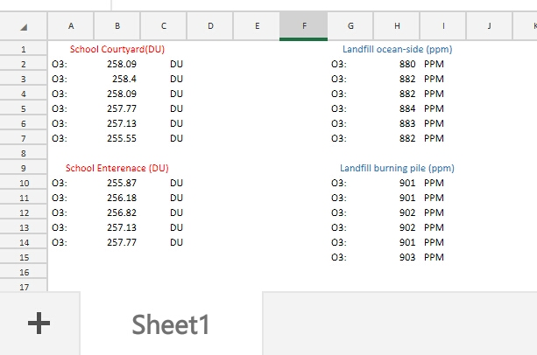

The measurements at school were measured in Dobson Unit and at the Dump in parts per million.

**The average calculation for each is as follows:**

* School courtyard: 257.504 DU
* School entrance: 256.754 DU
* Landfill ocean side: 882 ppm (882.2)
* Landfill burning pile: 902 ppm (901.6)

While taking the measurements at the university the levels remained pretty much the same. We did measure the ozone level at the university in Dobson Units, so that could make a difference if we would convert it to ppm. The highest measurement is 258.05 DU in the school courtyard and the lowest was 255.549 DU also in the school courtyard.

While taking the measurements at Parkietenbos we noticed that the ozone levels did change quite a bit when we changed locations. But when we were at the ocean-side it did stay around the same measurements, and the same goes while we were near the burning pile. The lowest being at 880 ppm and the highest being 903 ppm. The numbers were at their lowest near the landfill ocean-side (880 ppm) and they were at their highest near the the landfill burning pile (903 ppm). 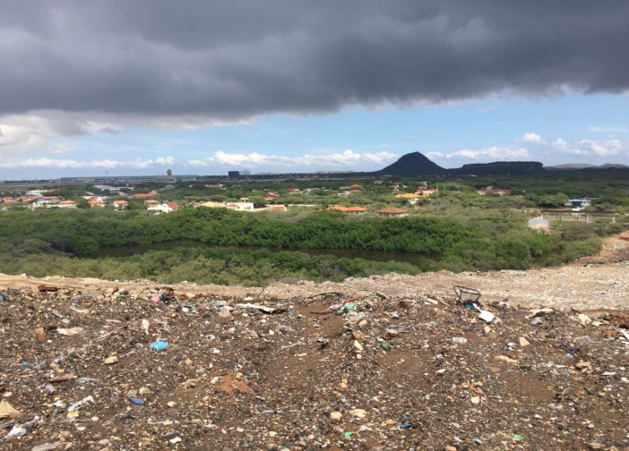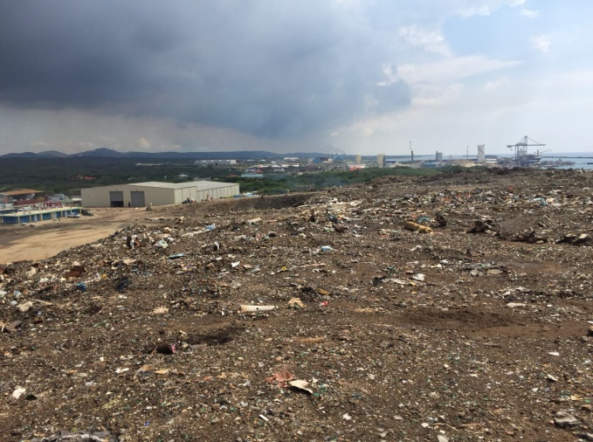

The weather on during the week was partially rainy but mostly sunny but oct 30th (the day of the dump) was mostly sunny and humid. There were some dark clouds at the dump and it rained briefly.

The world average of the ozone is 300 DU and in the area of Aruba the average is supposed to be 260DU. According to our calculations around the school the DU is 2-4 below normal which means it is relatively normal. While at the dump we could not determine whether the ozone was high or not due to us only being able to find and determine the levels of the ozone in DU and we don’t know how to calculate ppm to DU because we could not find the formula online. According to the calculations from school Aruba is in the safe zone compared to the rest of the world where the ozone there is relatively high. Aruba emits a lower amout of greenhouse grasses than the rest of the world.

